1. **Display the current time and date**

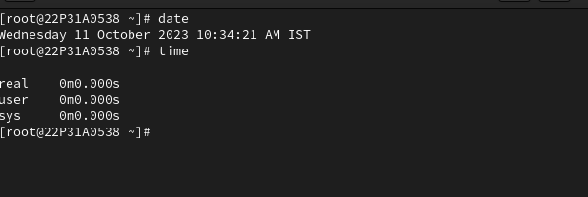

2. **Use the wc command and bash shortcuts to display the size of /etc/passwd**

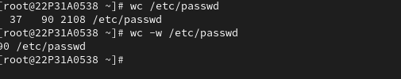

3**. 3. Display the first 10 lines of /etc/passwd**

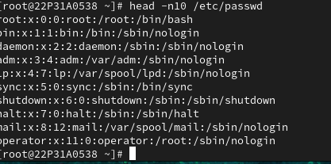

**4. Display the last 10 lines at the bottom of the /etc/passwd**

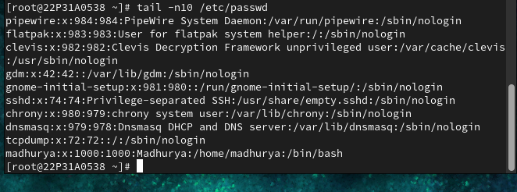

**5. Repeat the previous command, but use the -n 20 option to display the last 20 lines in the file**

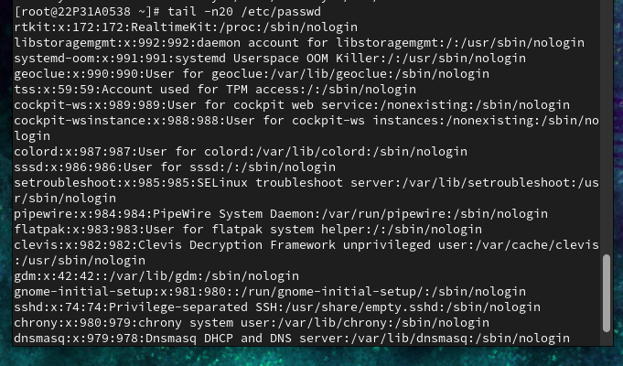

**6. Create the following users, groups and group memberships:**

a. Create a group named admin.

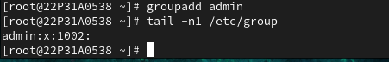

b. Create a user Krish who belongs to admin as a secondary group.

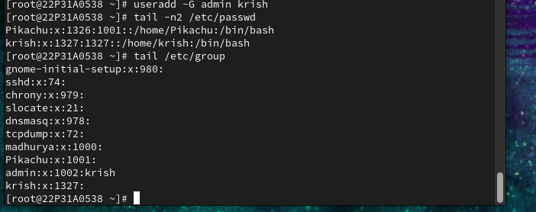

c. Create a user Veeru who does not have access to an interactive shell on the system and who is not member of admin. 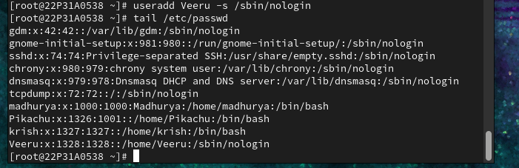

d. The users Krish and Veeru should all have password of password.

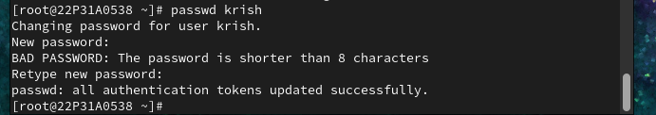

**7. Log into your Krish account**

In Krish Home Directory a. create six files with names of the form songX.mp3.

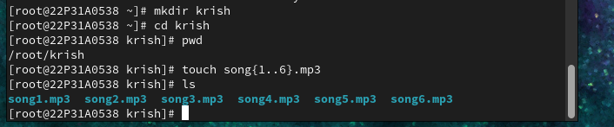

b. Create six files with names of the form snapX.jpg.

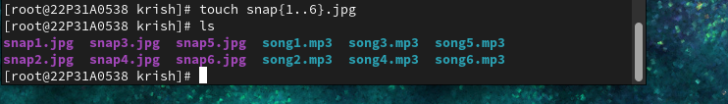

c. From your home directory (Krish Home Dir), move the song files into your Music subdirectory, the snapshot files into your Pictures subdirectory

moving the song files into Music subdirectory

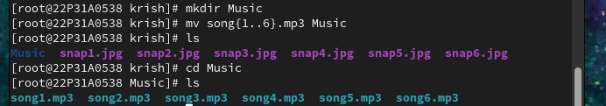

moving the snap files into Pictures subdirectory

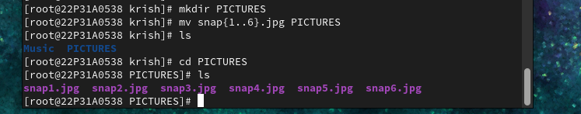

**10. Partitions and Disks**

a. Add one hard disk of type SATA of size 5GB to your VM.

1.Adding hard disk :

In the partitions concept, that we first create the hard disk with the required hard disk and the GB

And then checking whether the hard disk is created or not with an lsblk command and then

Creating an partition of the hard disk with the required GB the save it into the folder where we want

Store the partition of the hard disk and then finish the creation of the partition .

Next, check the partition with the command blkid whether it was created or not

After checking creating an type of the file system with the types like ex:xfs,ext4 …etc.

Mounting the partition :

Creating one required directory and the mounting that directory into the partition with the command called mount /dev/partition(sda1) /mnt/directory that we created

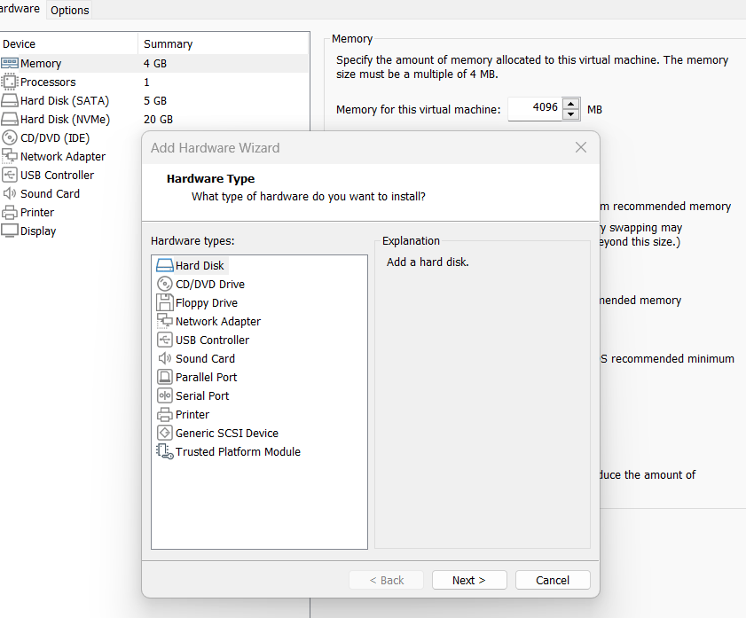

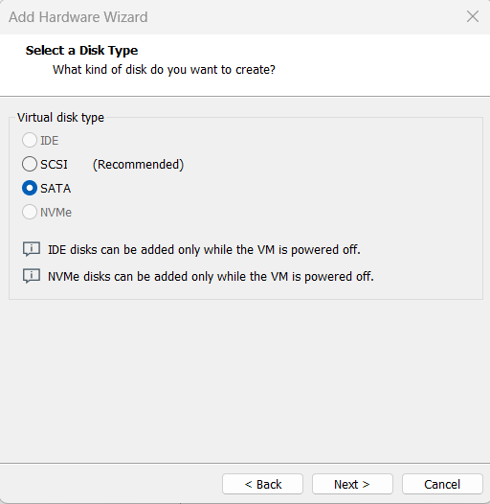

Adding Sata and storing that hard disk with the 5.0GB:

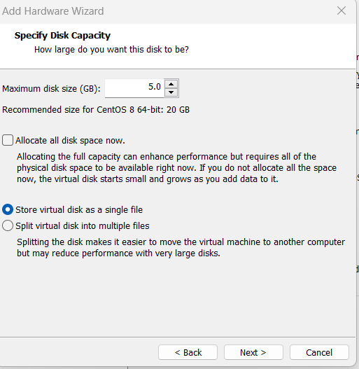

Creating an sdb hard disk with the 5.0GB

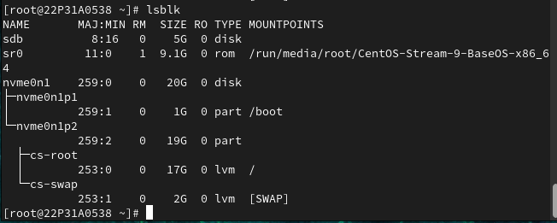

Making an partition(sdb1) 3GB

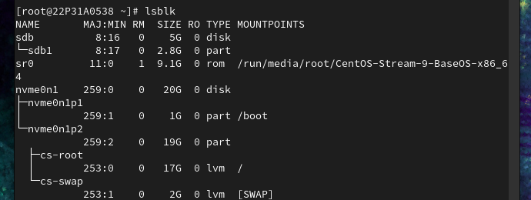

File system is xfs

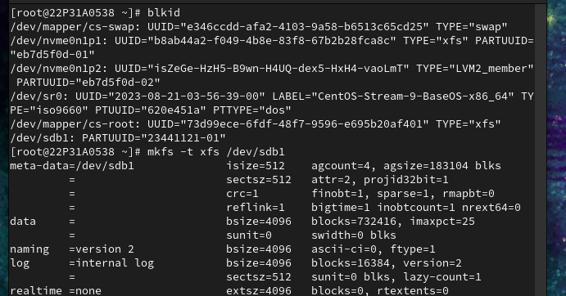

Mounting the partition with the thub

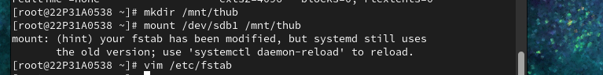

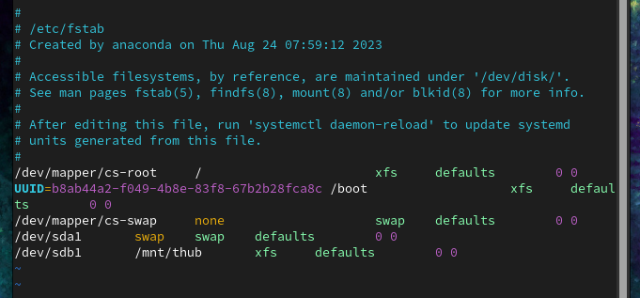

Final output with the partition and the mounting

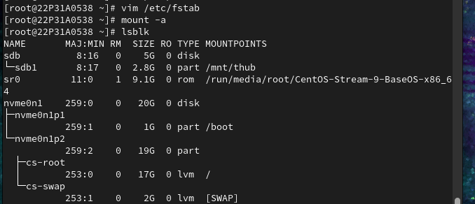

**11. Swap Space**

a) Add one more hard disk of type SATA of size 1Gb to your VM

b) Create a swap partition of size 512Mb

c) Do permanent Mounting

creating an new hard disk sdc

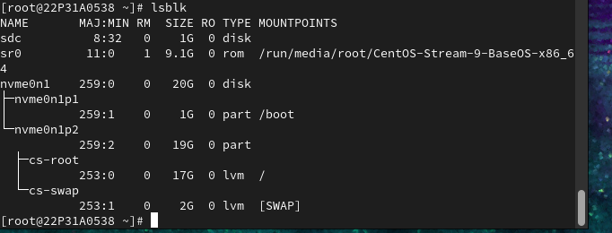

Creating an partition sdc1

In this swap method we have save before the partition as the we write the hexacode and then save the swap partition (note : the swap method is same as the partition method only)

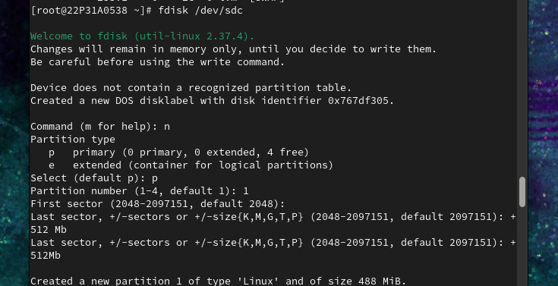



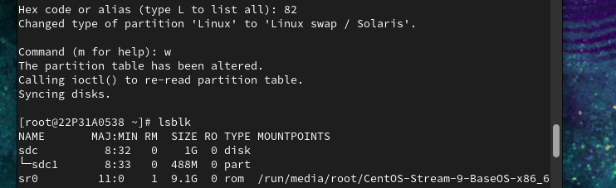

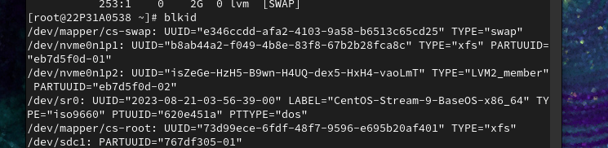

Making swap

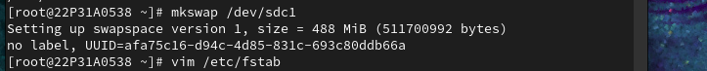

Final output of the swap partition

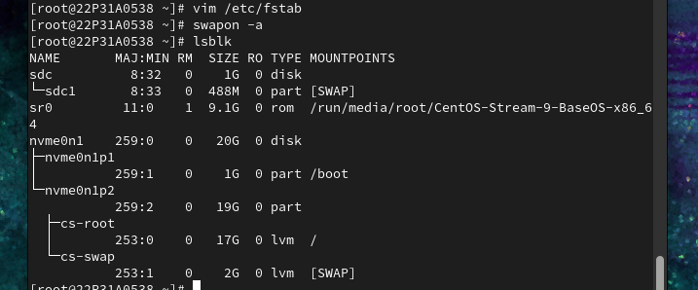

9. **Create a user account**

a. Create a new user with UID 1326 and user name as Pikachu

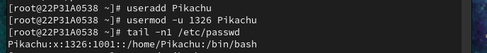

b. Set password as Thub@123

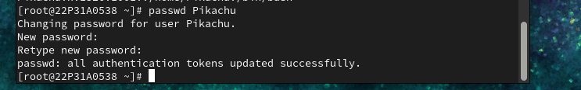

**8.. Create a collaborative directory /common/admin with the following characteristics**

a) Group ownership of /common/admin is admin.

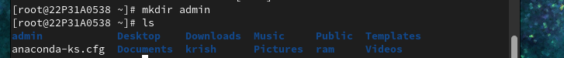

b) The directory should be readable, writable and accessible to members of admin, but not to any other user.

